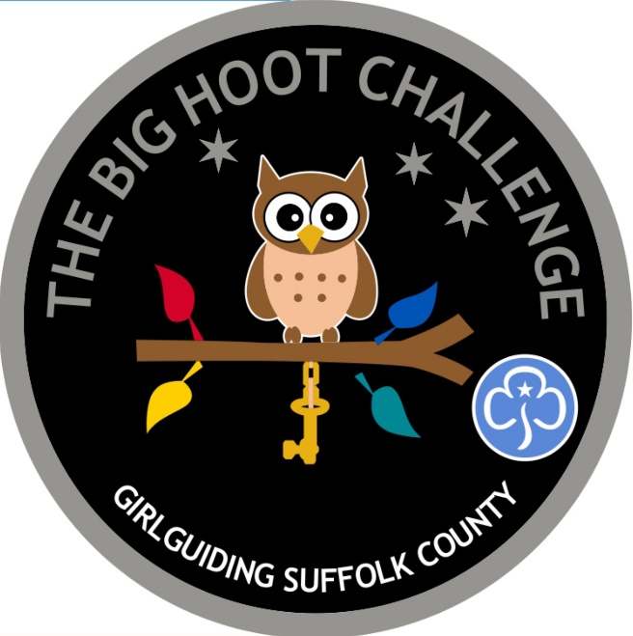

The Big Hoot Challenge

This challenge has been designed as part of The Big Hoot Trail happening in Ipswich in Summer 2022 to raise funds for St Elizabeth Hospice. Girlguiding Suffolk have sponsored a Little Hoot as part of their Education Programme working with Schools and Voluntary Groups. Profits made from the sale of the badges for this challenge will help with the Sponsorship Cost and hopefully make a fun filled programme for this Summer!

To gain the badge you need to complete;

Rainbows – 4 challenges

Brownies and Guides – 5 challenges

Rangers, Leaders and Trefoil Guild – 6 challenges

You should do at least one challenge from each section

Girlguiding Suffolk hope you enjoy doing this challenge!
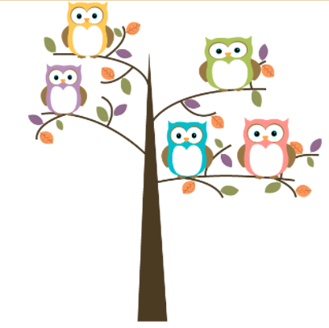

Be Creative

- Design and name our Little Hoot – if you entered a design into the County Wide competition (closed 31/1/22) then you can tick off one challenge. If not, you can still design one using the attached template!
- Decopatch an Owl
- Make and decorate owl shaped biscuits or make cupcakes and decorate with an owl face decoration.
- Make an owl with hamma beads (Pinterest has some great designs)
- Cross stitch an owl (Pinterest has free downloadable designs to suit all abilities)
- Make an owl out of recycled materials
- Make an owl mask
- Make owl pellet truffles (recipe on appendix)
- Nature needs bugs and bugs need homes – make a bug house (lots of ideas online)
- Do an owl origami
- Paint an owl onto a pebble and leave it somewhere for others to find.
- Make a no-sew owl (see appendix)
- Make a fluffy owlet (see https://www.barnowltrust.org.uk/owl-facts-for-kids/owl-crafts/owl-cardboard-tube-craft/)
- Do another owl inspired craft

Get Outdoors
- Visit the Big Hoot Trail being held in Ipswich Summer 2022 – how many owls can you see in one evening? Alternatively go on a similar trail wherever you are.
- Have a selfie with Girlguiding Suffolk’s Little Hoot
- Visit Suffolk Owl Sanctuary – how many different breeds of owls do they have there?
- Arrange a visit to a Hospice or have someone from a Hospice visit your meeting to find out more about their work.
- Do the Midnight Walk, Bubble Rush or similar Hospice fundraising event.
- Do a scavenger hunt using the letters THE BIG HOOT TRAIL.
- Do a Night Hike or Penny Hike in the dark
- Do an owl themed wide game or Treasure Hunt

Learn & Play
- Write your own story or Poem about an Owl
- Owls are thought to be wise – play Kims Game or another memory game
- Play a ‘Pin the beak on the Owl’ game
- Owls have great eyesight – play Red Light / Green Light or similar spotting game
- Do the Owl Quiz attached as a ‘run around’ game
- Owls can see really well in the dark – play a game in the dark in your meeting place.
- Have an owl based storytime. Read the Owl & the Pussycat. Owl Babies.
- Read the Brownie Story and act out the story in sixes
- Learn some owl songs and poems
- Have an owl drive (like beetle drive)
You need one dice per group of 4. The girls work in pairs and each draw the same. They take it in turns to throw the dice. The idea is to draw an owl. Each owl part has a number. A body (throw a 6) a beak (throw a 5) two wings (throw 2 lots of 4) two eyes (throw 2 lots of 3) two feet (throw 2 lots of 2) and two inner eyes (throw 2 lots of 1). Total Owl – 31.

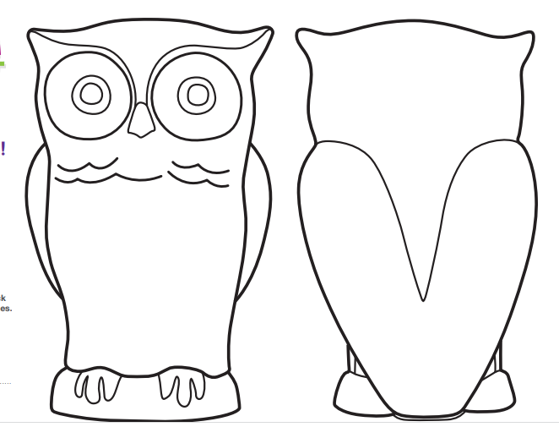

Make your own Owl pellet chocolate truffles
Looks yukky – tastes great!
Impress your friends and enjoy a delicious treat with this easy recipe.
Ingredients
- 250ml double cream.
- 325g best quality milk chocolate chopped or broken into even sized chunks.
- 1/2 packet of finely crushed digestive biscuits.
- Cocoa powder, sifted.
- Dessicated coconut for covering.

Method

- In a heavy based saucepan bring the cream up to simmering point.
- Cut the chocolate into evenly sized chunks and place into a glass mixing bowl.
- Pour the simmered cream onto the chocolate and mix well until smooth and glossy.
- Finely crush the digestive biscuits (wrap the biscuits in a freezer bag or cling film and crush to fine crumbs with a rolling pin). Add the crushed biscuits to the chocolate mixture as required until the mixture is stiff enough to hold together.
- Leave on a cold plate in a cool place for a little while, to cool and firm-up.
- When cooled enough to touch, take teaspoons of the truffle mixture, roll into pellet shaped ovals and dust with the ground cocoa powder and press on some dessicated coconut.
- Place your Owl pellet chocolate truffles in the fridge to set.

No Sew owl

You need: sock, brown, tan, orange, black felt. Two eyes, brown foam, hot glue gun.

Cut the bottom part of the sock off, all the way up to the heel. Stuff the cut off part leaving the top inch empty. Cut brown and orange circles for the eyes and glue one inch below the cut edge of the sock. Glue eyes to the centre of the circles. Cut a beak in black and glue it to the face as per the picture. To make the ear tufts fold the back side of the cut edge of the sock over the front and glue it to the front side of the owl covering part of the eye circles. Poke in the material formed on each side to make the ear tufts. Use a little glue to keep them closed. Cut two wings from the tan felt and glue to the sides of the owl. Cut two claw shapes from the brown foam and glue to the bottom of the sock.

Owl Quiz – set out 6 stations; A B C D plus TRUE and FALSE
1 How many Species of Owl are there in the world?
A Around 100
B Around 150
C Around 200
D Around 250
2 The largest species of Owl is:
A The Blakiston Fish Owl
B Great Grey Owl
C Long Earred Owl
D African Grass Owl
3 The smallest species of Owl is;
A Little Owl
B Elf Owl
C Short Earred Owl
D Barn Owl
4 Owls can see if total darkness
A True
B False
5 Owls can Swivel their heads up to;
A 180 degrees
B 220 degrees
C 270 degrees
D 360 degrees

6 Owls have Binocular Vision which means they see with both eyes straight ahead like humans:
A True
B False
7 Owls have how many Eyelids?
A 1
B 2
C 3
D 4
8 Owls don’t have a sense of smell
A True
B False
9 Owls don’t hear too well
A True
B False
10 Owls swallow their prey whole & regurgitate it 8 hours later as a pellet.
A True
B False
11 Owls mate in:
A Winter
B Spring
C Summer
D Autumn
12 Owls do not construct nests
A True
B False
13 Owls live in Groups
A True
B False
14 Baby Owls are called
A Pups
B Chicks
C Owlet
D Kittens
15 Owls incubate their eggs for;
A 18-25 days
B 29-35 days
C 37-45 days
D 47-55 days
16 A group of owls is called
A PRIDE
B MURDER
C FLOCK
D PARLIAMENT
17 Owls are far sighted so can only see things in the distance
A True
B False
18 All owls hoot
A True
B False

Answers
    - C
    - A – Its very rare and endangered
    - B
    - B – they do need some light to see
    - C
    - A
    - C – a top lid, bottom lid and a third transparent membrane which moves sideways at incredible speed
    - A
    - B – they have incredibly sensitive hearing which helps them locate prey
    - A – the pellet is all the bits they cannot digest like bones / fur
    - B
    - A – they use holes in trees, barns, on the ground or old nests
    - B – they are very solitary birds
    - C
    - B
    - D
    - A
    - B – they screech, whistle, growl, rattle, bark or hiss!

BADGE ORDER FORM

Once you have completed The Big Hoot Challenge you can buy badges from Craftability, 4 St Lawrence Street, Ipswich, IP1 1DN for £1.
Alternatively you can order by post by completing the below form and posting to Gillian Smith, 9 Brandeston Close, Gt Waldringfield, Sudbury, CO10 0XY.
UNIT: _____________________________________________________
COUNTY: __________________________________________________
LEADERS NAME: _____________________________________________
ADDRESS FOR POSTAGE OF BADGES: ______________________________________________________________________________________________________________________
PHONE & EMAIL (for queries) ___________________________________________________________
TOTAL NUMBER OF BADGES @ £1 EACH __________________
Please add postage * as follows;
1-12 Badges £1.00
13-100 Badges £3.00
100 plus Badges – please contact for amount
TOTAL AMOUNT ENCLOSED £_____________________

Please make cheque payable to Suffolk Guide Association.
Challenge ends 31 March 2023
*Postage prices may change and pack will be updated.

